Project Development Phase
Model Performance Test

Date | 20 February 2026
Team ID | LTVIP2026TMIDS52591
Project Name | Exploratory analysis of rain fall data in india for agriculture
Maximum Marks

Model Performance Testing:
Project team shall fill the following information in model performance testing template.

S.No. | Parameter | Values | Screenshot
1 | Model Summary | Regression model with 5 epochs training | 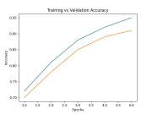
2 | Accuracy | Training Accuracy - 95%  Validation Accuracy - 91%
3 | Fine Tuning Result | Validation Accuracy - 96% | 